Entry Form

NORTHERN IRELAND TABLE FOOTBALL ASSOCIATION
2005 Belfast International Grand Prix
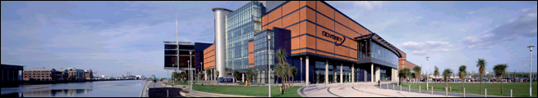
W5 Discovery Centre, Odyssey, Belfast
Sat 14th May 2005, 9am - 6pm

DATE:
Saturday 14th May 2005, Starting 9:30am sharp (Registration 9am)

VENUE:
W5 Discovery Centre in the BT Atrium
Odyssey, 2 Queen's Quay, Belfast BT3 9QQ
Tel: +44 (0)28 9046 7700
Web Address: www.w5online.co.uk/

COMPETITION MANAGER:
Simon Stewart, Email: belfastgp@hotmail.com
Telephone: +44 (0)28 9046 7700 from 9am - 5pm

CATEGORIES & FEES
Open: £10, Veteran: £7, Junior: £5, Female: £5
This includes free entry into W5 Discovery Centre

Due to time restrictions, entrants for the Open category may not enter any other category. There will be a Plate for players eliminated from Open groups & a Penalty Shoot-out for spectators from 2pm-4pm.

ENTRANTS
Name | Address | Phone | Birth Date | Category | Entry fee

You can enter by emailing Simon Stewart, belfastgp@hotmail.com or send your completed entry form to:

Simon Stewart
c/o W5 Discovery Centre
Odyssey,
2 Queen's Quay,
Belfast BT3 9QQ
Northern Ireland
United Kingdom

Simon is contactable by phone on +44 (0)28 9046 7700 from 9am - 5pm
For further information, see Northern Ireland Table Football Association web site www.nitfa.org.uk
DIRECTIONS

W5 is part of Odyssey, Northern Ireland’s Landmark Millennium Project. Ideally located in central Belfast, on the banks of the River Lagan, it is within walking distance of major shops, restaurants & attractions. It is easily accessed by air, sea, road and rail. Upper floors of W5 have spectacular views of Belfast’s cityscape and far beyond.

Road
Odyssey is clearly signposted on all major approach roads

From the North
Approaching Belfast on the M2 follow the signs onto the M3. Leave the M3 at the Queen's Island exit. Turn left at the lights onto Sydenham Road, the Odyssey Arena is on your right and car park on your left.

From the South/ Republic of Ireland
From M1 approaching Belfast cross straight onto Broadway and then straight onto the Westlink following signs for M3/City Airport. Once on the M3 take the first exit entitled 'Queen's Island'. Turn left at the lights onto Sydenham Road, the Odyssey complex is situated on the right and car park on the left.

From Belfast City Centre
Follow signs for A2 Bangor onto Queen Elizabeth Bridge. Keep in left lane and immediately after crossing the River Lagan turn left onto Queen's Island. Follow the road for ¼ mile, the car park is on your right.

Parking
Odyssey has its own car park with 1,500 spaces immediately opposite the Odyssey Centre. Costs are £0.60/hour or £2.20 for up to 6 hours if paid in advance.
Foot
From City Hall
From Donegall Square North (front of City Hall) proceed along Chichester Street until it intersects with Victoria Street. Turn left onto Victoria Street and proceed until Ann Street. Turn right onto Ann Street. Cross at the end of Ann Street to Queen's Bridge. Turn left and walk along the city side of the river until you come to the Queen Elizabeth Bridge. Cross the river over this bridge. Once over the bridge turn left onto Queen's Quay and walk for ¼ mile the entrance to the Arena is on the left.
From Central Station
W5 is ten minutes walk from Central Station. From the entrance to Central Station turn left and proceed along East Bridge Street. Turn right onto Oxford Street past the Waterfront Hall until you come to Queen Elizabeth Bridge. Cross this bridge and having crossed it, turn left onto Queen's Quay and proceed along this road until you reach the Arena entrance on the left

Bus
It is only five minutes walk from the Laganside Bus Centre via Queen Elizabeth Bridge or Lagan Weir Bridge & one mile from Europa Bus Centre. A Flexibus service operates between Europa Bus Centre and Odyssey every 30 min. For details of bus services, telephone Translink on +44 (0)28 9033 3000.

Rail
Central and Great Victoria Street Stations are just one mile from Odyssey, with Dublin only two hours away by train. Regular services also operate to Londonderry, Bangor, Larne, Coleraine, Portrush and the suburbs of the city. For details of train services contact Tel: +44 (0)28 9089 9411.

Sea
W5 is situated across from Belfast Harbour, almost opposite the Seacat terminal and close to Stenaline HSS terminal, which combined, operate daily services to and from Scotland (Troon, Stranraer) and England (Heysham, Liverpool).

Air
Odyssey is only 2 miles from Belfast City Airport and 15 miles from Belfast International Airport. Daily flights are available from all four London airports, as well as Birmingham, Manchester, Glasgow and around 10 other British airports. International flights are available from a number of Eurpoean cities & from North America.
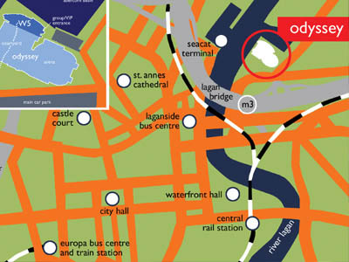

DUBLIN GRAND PRIX Sunday 15th May 2005
This will take place on the day after the Belfast Grand Prix.
To enter, email Gary Moore garymoore2@eircom.net or telephone 00353 (0)857134119

There is a train from Belfast Central Station to Dublin Connolly Station, departing at 20:10 on the Saturday evening, journey time 2 hours. Alternatively, a bus leaves Belfast Europa Bus Centre at 20:15, arriving in Dublin 3 hours later. There will be also be some places available in cars, although space will be limited. Let us know in advance if you require this. First come, first served.

Trains - Belfast (Central Station) & Dublin (Connolly Station) are linked by 8 trains daily in both directions (5 on Sundays). The 'Enterprise' express train takes 2 hours. Standard fares are £23 / €33 one way and £33 / €48 round trip (valid one month). Cheap day returns are also available for £25 / €35 (except Fridays & Sundays). Timetable at http://www.translink.co.uk/present/Saturday

Buses - Ulsterbus Goldline Express Service, departing from Belfast Europa Bus Centre
Day Return Fare : Belfast–Dublin : £14.50
Period Return : £17.90 Adult (valid for 1 month) Children £10.80; Student £14.50

For further details, telephone Translink on +44 (0)28 9033 3000.

